

Centre Name: ACE-HCMC-2-FPT (VN.033)

Address: 590 Cách Mạng Tháng 8 Street, District 3, Ho Chi Minh City, Viet Nam



WEB PHOTO

SHARE

Installation Guide

|  |  |  |  |
| --- | --- | --- | --- |
| **Faculty:** | | **Mr. Nguyen Ngo Phuoc** |  |
| **Batch No:** | | **F2-10-1203-T0** |  |
| **Group No:** | | **01** |  |
| **Student** |  | **Full Name** | **Roll No.** |
|  | 1. | NGUYEN VU HUNG | STUDENT636555 |
|  | 2. | TRAN VAN HAI | STUDENT630717 |
|  | 3. | LE NGOC NHUT | STUDENT636217 |
|  | 4. | NGUYEN ANH TUAN | STUDENT576665 |

September 2013

# Table of Contents

Table of Contents 2

I. Setup Database 3

1. Requirement 3

2. Create database 3

II. Deploy project into GlashFish Server 6

1. Requirement 6

2. Start GlashFish server 6

3. Deploy database resource 6

4. Deploy Application 9

# Setup Database

## Requirement

* Microsoft SQL Server 2008 R2
* Microsoft SQL Server Management Studio version 10.50.2500.0

## Create database

* Drop database if exist: WebPhotoShare
* Create a new database named: WebPhotoShare
* Right click on WebPhotoShare database, Select Task 🡪 Restore 🡪 Database

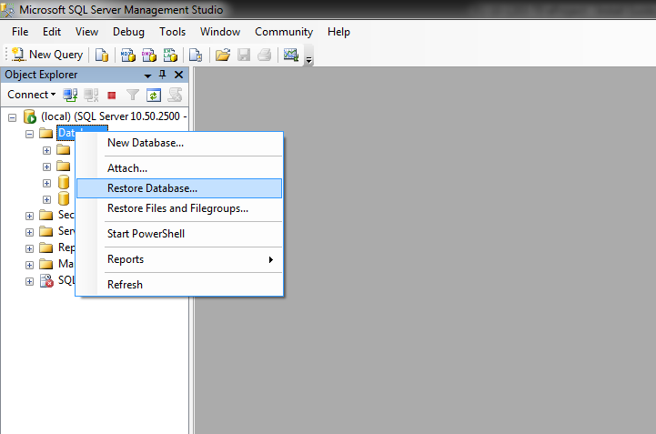

* On Destination for restore
  + To database: WebPhotoShare
* On Source for restore, select From device, Locate WebPhotoShare.bak in Database folder

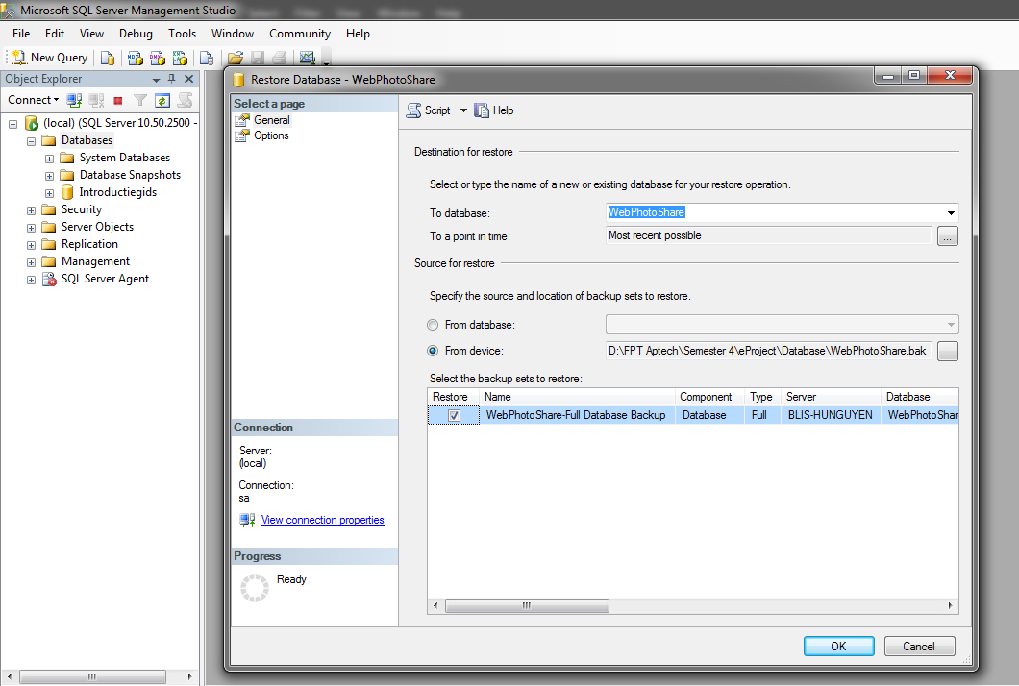

* Wait for restore process

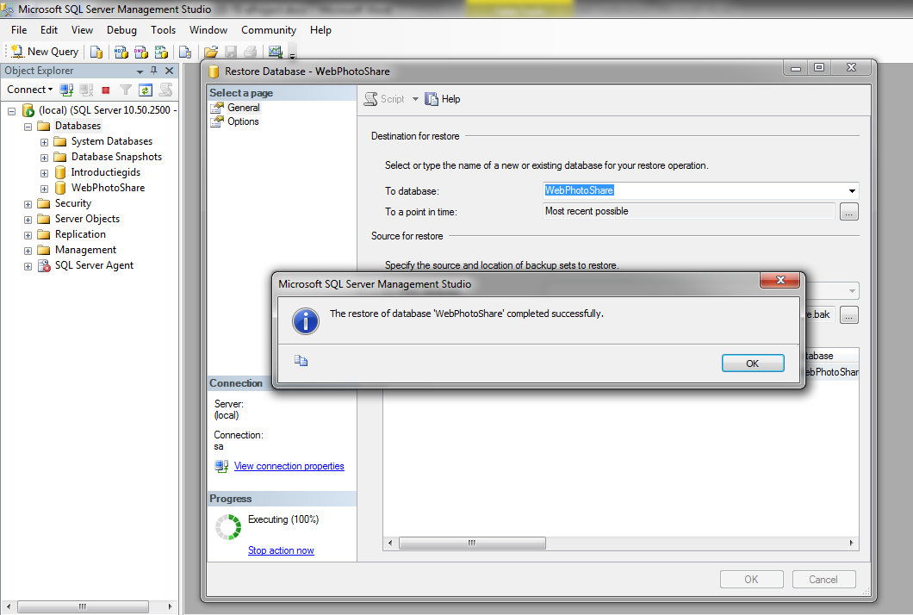

# Deploy project into GlashFish Server

## Requirement

* GlassFish Server Open Source Edition 4.0
* JDK jdk1.7.0_25

## Start GlashFish server

* Go to: %glassfish-root%/glassfish/bin : run startserv.bat
* Waiting until server started

## Deploy database resource

* Open <http://localhost:4848/> in web browser
* Wait until Glassfish server Administration Console loaded
* On Common Tasks list go Resources>JDBC>JDBC Connection Pools : click New

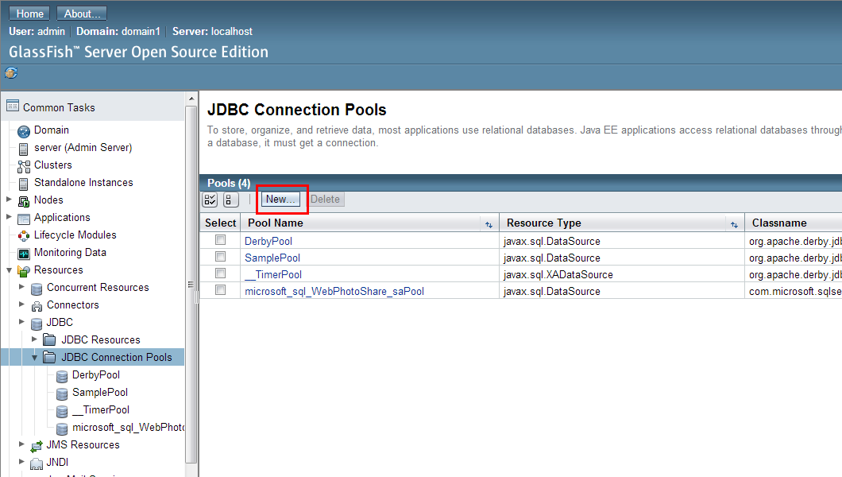

* Config like the picture below then press next

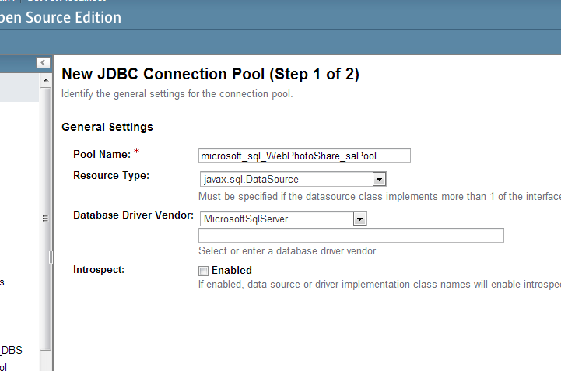

* + Pool Name: microsoft_sql_WebPhotoShare_saPool
  + Resource type: javax.sql.DataSource
  + Database Driver Vendor: MicrosoftSqlServer
* In the next page scroll down to the Additional Properties Table and enter username and password of database and some information like this

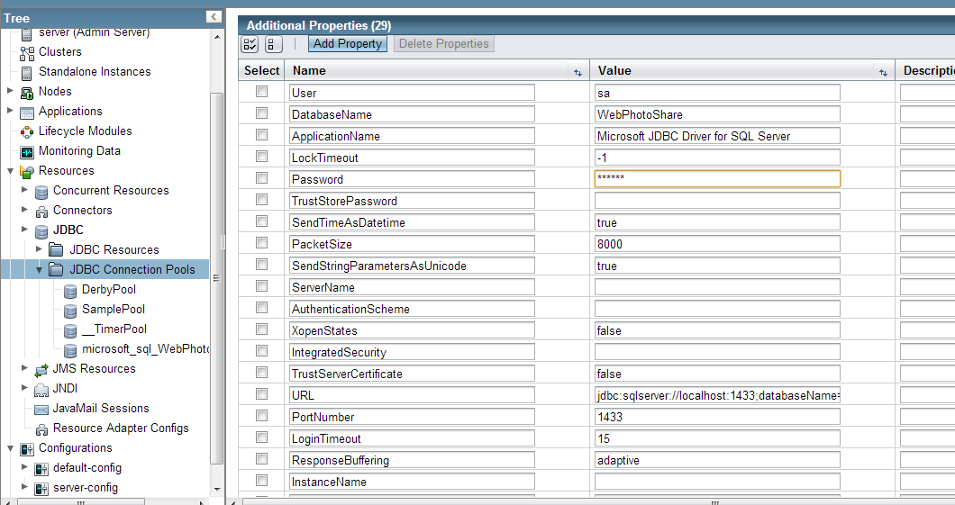

* + Database name: WebPhotoShare
  + URL: jdbc:sqlserver://localhost:1433;databaseName=WebPhotoShare
  + User: sa
  + Password:
* Click Finish
* On Common Tasks list go Resources>JDBC>JDBC Resoucres click New then Enter these value

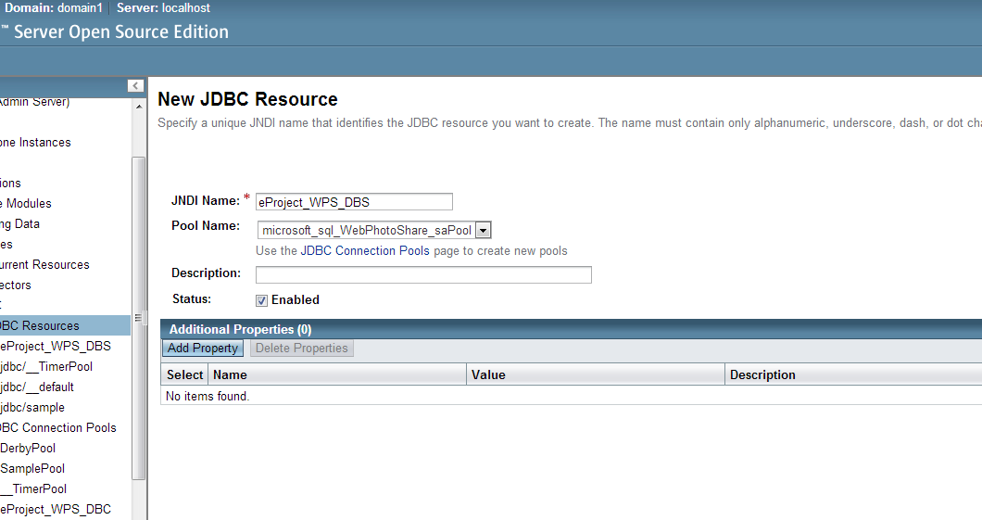

* Click OK

## Deploy Application

* On Common Tasks, click Applications and then click Deploy

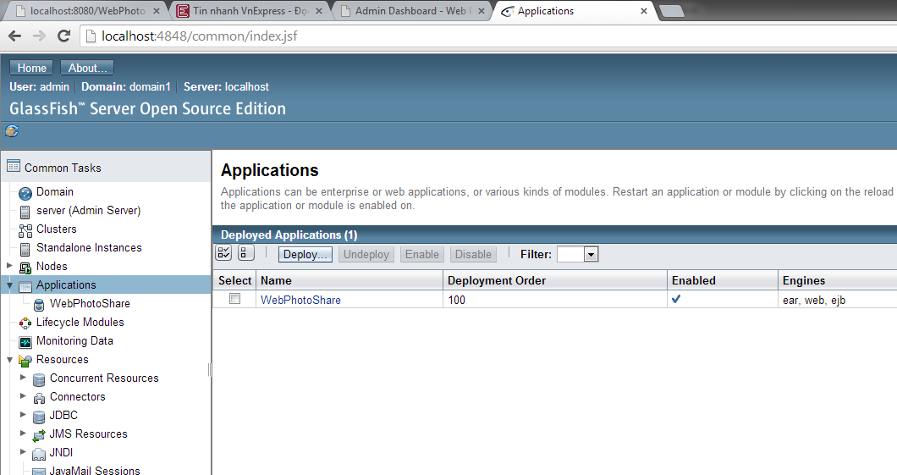

* On Packaged File to Be Uploaded to the Server: locate WebPhotoShare.ear in folder Source Code

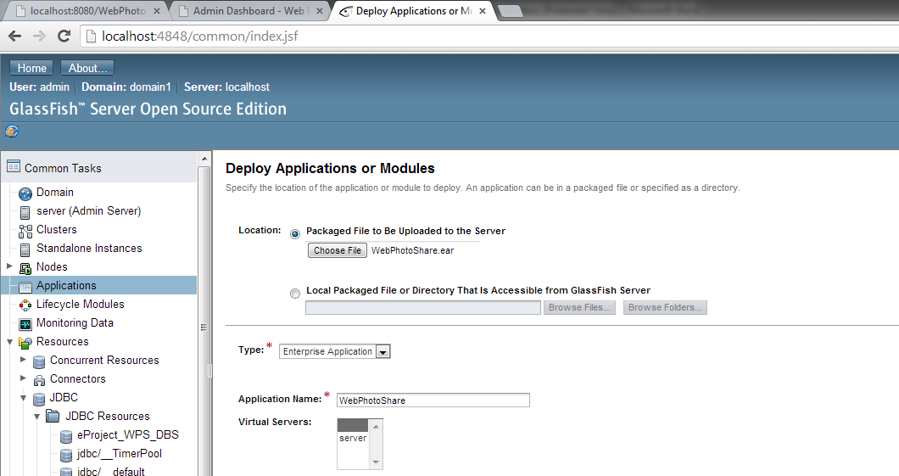

* Then click Deploy
* On successful, the application name will be display

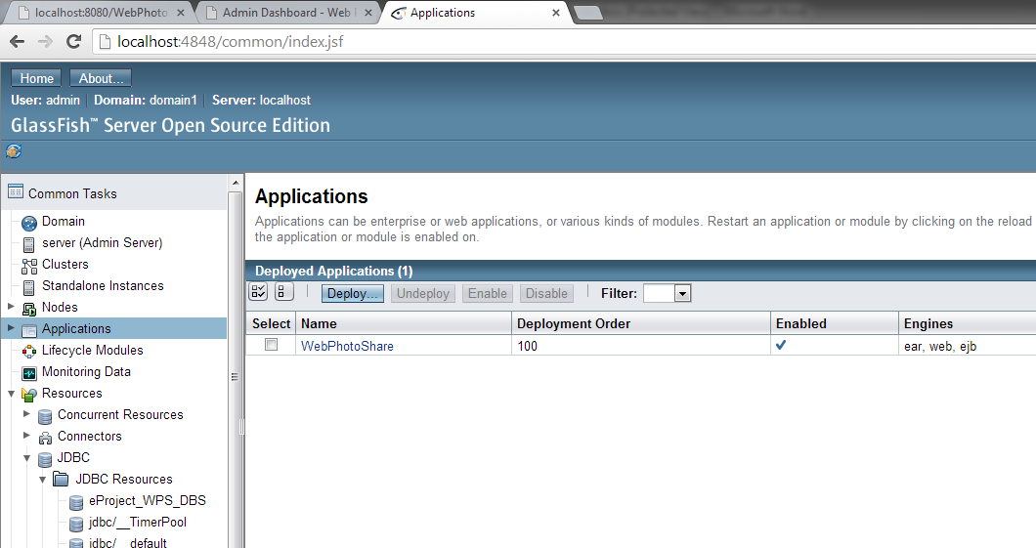

* Click on the name of application: WebPhotoShare
* Scroll down until see the Launch link

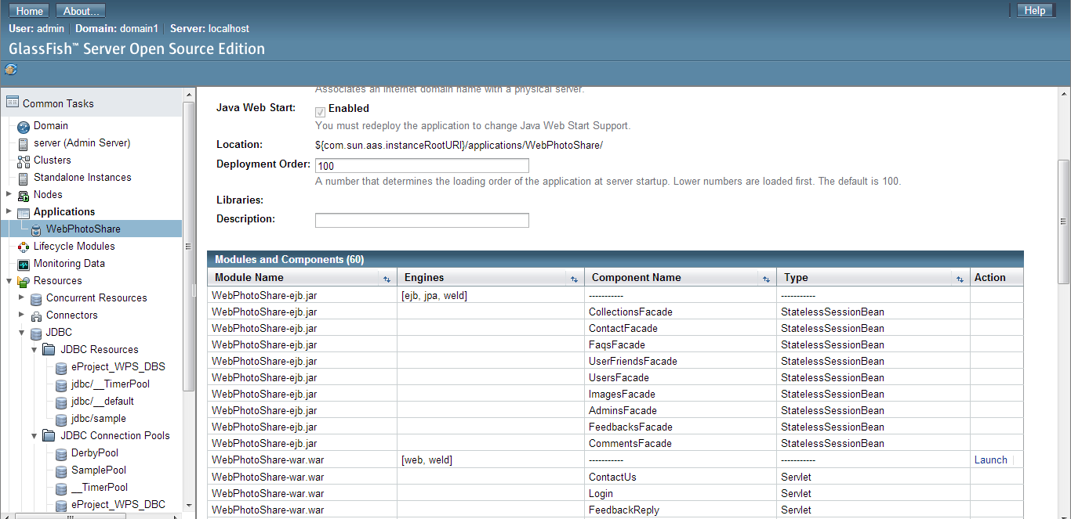

* Click on this link: Launch
* Copy profiles, uploads in Source Code\WebPhotoShare\WebPhotoShare-war\web to   
  %glassfish-root%/glassfish/domains/domain1/applications/WebPhotoShare
* Click the link to continue

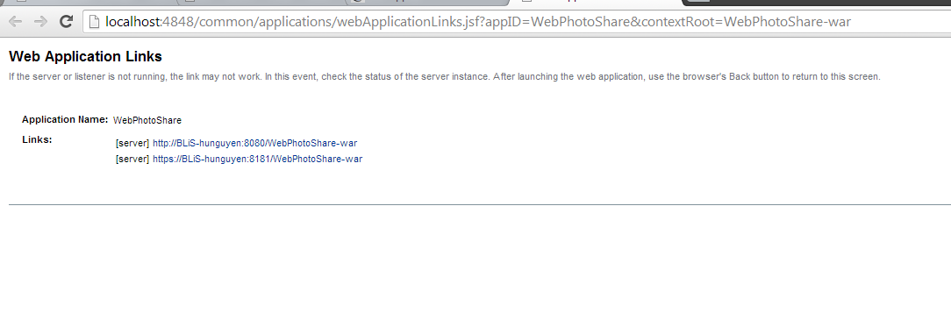

* This is default page for visitors
* Welcome to WebPhotoShare website

